

T

L

W

**Estate Planning**

**MAIN ASSET**

C

B

D

JAN

JIM

CHILDREN

**6 YEARS BEFORE**

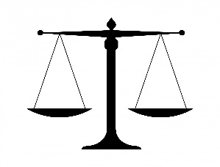 £

M

**What could have the man done ?**



C

B

D

Jan

Jim

CHILDREN

**6 YEARS BEFORE**

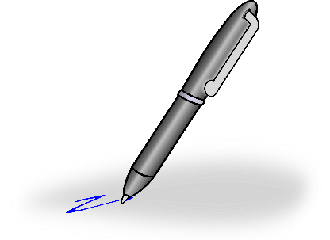

H

P



**WHAT DOES ESTATE PLANNING DO ?**





[This Photo](http://commons.wikimedia.org/wiki/File:2011_Arrow_black_curving_axe_67%C2%B0_attraction.svg) by Unknown Author is licensed under [CC BY-SA](https://creativecommons.org/licenses/by-sa/3.0/)



F L E P

T

W

L